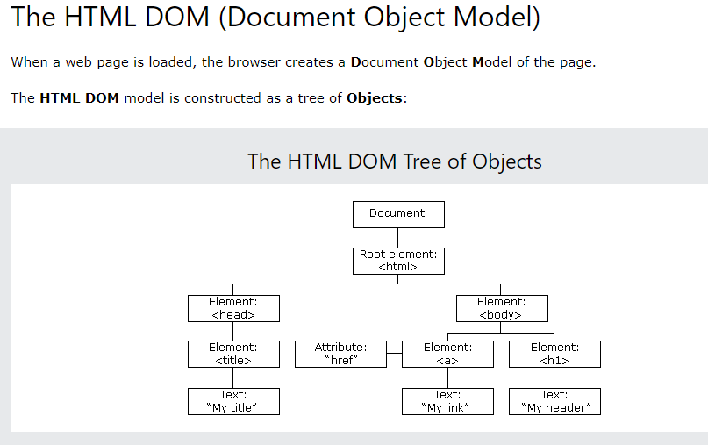

What is the DOM?

The DOM is a W3C (World Wide Web Consortium) standard.

The DOM defines a standard for accessing documents:

*"The W3C Document Object Model (DOM) is a platform and language-neutral interface that allows programs and scripts to dynamically access and update the content, structure, and style of a document."*

The W3C DOM standard is separated into 3 different parts:

* Core DOM - standard model for all document types
* XML DOM - standard model for XML documents
* HTML DOM - standard model for HTML documents

What is the HTML DOM?

The HTML DOM is a standard **object** model and **programming interface** for HTML. It defines:

* The HTML elements as **objects**
* The **properties** of all HTML elements
* The **methods** to access all HTML elements
* The **events** for all HTML elements

